**Körber reaches strategic partnership with Taibang Biologic to future-proof blood product manufacturing and increase production efficiency**

**泰邦生物与柯尔柏达成战略合作伙伴关系，共同构建面向未来的血液制品生产流程，提升生产效率**

**Lüneburg, Germany / Tai’an, China, 4 September 2024. Taibang Biologic Group, a leading Chinese blood product manufacturer, has signed a strategic partnership agreement with the international technology group Körber. Amidst the heightened Chinese regulations for blood products, Körber will support the company in digitalizing its manufacturing and inspection processes, ensuring safety and compliance.**

德国吕讷堡/中国泰安，2024年9月4日。国内综合性血液制品巨擘泰邦生物集团与国际技术集团柯尔柏签署了战略合作协议。在当前日益严格的血液制品监管环境下，柯尔柏将助力泰邦生物实现生产与检验环节的数字化转型，以确保产品的安全性与合规性。

Within the partnership, Körber will provide comprehensive support to Taibang in various areas, including the implementation of software products, inspection and packaging machines, training, technology, project consulting, and the assistance for development of production information platforms. The collaboration encompasses in-depth cooperation across project planning and execution, production, and maintenance, as well as sharing of relevant solutions and experiences.

在合作过程中，柯尔柏将为泰邦生物提供多领域的全面支持，包括但不限于软件产品的实施、灯检设备及包装设备、培训、技术指导、项目咨询，以及协助开发生产信息化平台。双方将在项目规划设计、执行、生产维护以及相关解决方案和经验分享等层面展开深入合作。

Taibang is currently implementing the newest version of Werum PAS-X MES, Körber’s market-leading manufacturing execution system for pharma, biotech and cell & gene therapy production, at its manufacturing base. The MES is expected to facilitate digital transformation and upgrades in areas such as processes, product quality control, and production efficiency, thereby fostering high-quality development in the blood products industry. PAS-X MES will be deployed as a full-scale MES at two Taibang sites – one in Tai’an and the other in Guiyang – covering complex processes from plasma melting to the finished product.

泰邦生物目前正在其生产基地实施最新版本的PAS-X MES。PAS-X MES 是一款前沿的生产执行系统，适用于制药、生物技术和细胞基因治疗行业的生产流程。该生产执行系统有望助力泰邦生物在工艺流程、产品质量控制、生产效率等方面实现数字化转型和升级，推动血液制品行业的高质量发展。PAS-X MES 将在泰邦位于泰安和贵阳的两个生产基地全面部署，覆盖从融浆到最终产品的复杂流程。

“As a national high-tech enterprise and one of the largest blood product groups in China, Taibang attaches great importance to R&D and production capacity,” says Hao Zhang, IT Director of Taibang, “Since Körber is an expert in technological innovation in the pharmaceutical industry worldwide, we believe that this cooperation will further enhance our overall strengths. Aligning with international cutting-edge digital solutions will enable us to increase production efficiency and quality, providing patients with safer blood products.”

“作为国家级高新技术企业、全国最大的血液制品企业集团之一，泰邦生物非常重视研发和生产能力，”泰邦集团信息化负责人张昊表示，“柯尔柏是国际制药行业技术创新方面的专家，相信这次合作将进一步提升我们的综合实力，我们与国际前沿的数字化生产体系接轨，也能有助于为患者提供更优质、更安全的血制品。”

Jerry Zheng, Managing Director of Körber Business Area Pharma China, adds: “We are pleased to establish a long-term strategic partnership with Taibang, which is an important milestone in our China business. Over the years, Körber has been helping customers in the pharma industry to achieve digitalization and information management with its end-to-end integrated technology solutions, enabling them to move quickly to the 'Factory of Excellence'. We look forward to writing a new chapter in the blood products industry together with Taibang.”

柯尔柏医药科技中国区董事总经理郑磊明也表达了他对此次合作的期待：“我们很高兴能与泰邦生物建立长期的战略合作伙伴关系，这是我们之间的一个重要里程碑。多年来，柯尔柏凭借端到端的综合技术解决方案，帮助制药业客户实现数字化、信息化管理，使客户快速迈入‘卓越工厂’。我们将全力支持泰邦生物的发展，期待共同书写血液制品行业的新篇章。”

The Chinese National Medical Products Administration (NMPA) recently unveiled a set of regulations for blood products, including the “Three-Year (2024-2026) Action Plan for Smart Supervision of Blood Products Production”. These regulations aim to expedite the digitalization process, establish standards for the visualization of blood product manufacturing and inspection, and stimulate the transformation of blood product manufacturing. Ultimately, these measures are designed to ensure the safety, efficacy, and quality control of blood products.

国家药品监督管理局（NMPA）近期发布了三个与血液制品相关的重要法规和指南，包括《血液制品生产智慧监管三年（2024-2026年）行动计划》，全面加快推进血液制品生产、检验环节信息化建设等工作，提出血液制品生产、检验环节信息化和可视化的相关要求，促进血液制品生产转型升级，切实保障血液制品安全、有效和质量可控。

Körber's software solutions, such as Werum PAS-X MES, are of great importance here. The strategic partnership will accelerate Taibang’s pace of product research and development with a commitment to enhancing product quality and production efficiency.

柯尔柏的软件解决方案，尤其是维隆PAS-X MES，在应对法规挑战中扮演着关键角色。通过建立战略合作伙伴关系，泰邦生物将加快产品研发步伐，致力于提升产品质量和生产效率。

**Pictures**

**图片**

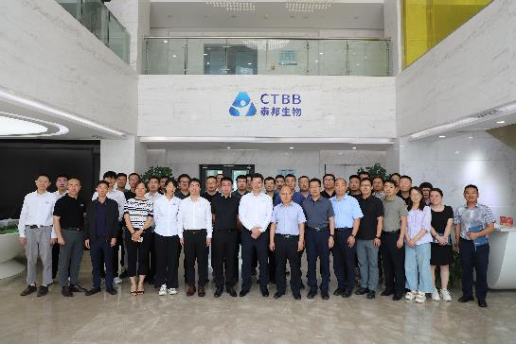

Cooperation kick-off at Taibang

泰邦生物的合作项目启动

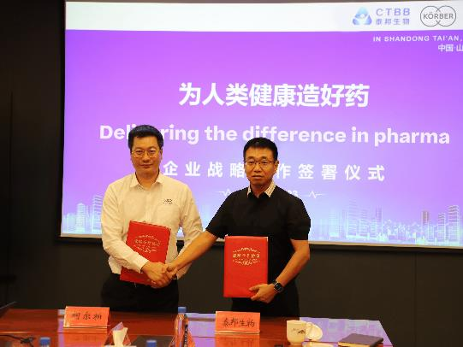

Signing ceremony: Jerry Zheng, Managing Director, Körber BA Pharma and Hao Zhang, IT Director, Taibang (from left)

签约仪式：柯尔柏医药科技中国区董事总经理郑磊明先生与泰邦集团信息化负责人张昊先生（自左至右）出席了该仪式。

**About Körber**

We are Körber – an international technology group with more than 12,000 employees at over 100 locations worldwide and a common goal: We turn entrepreneurial thinking into customer success and shape the technological change. In the Business Areas Digital, Pharma, Supply Chain, and Technologies, we offer products, solutions and services that inspire. We act fast to customer needs, we execute ideas seamlessly, and with our innovations we create added value for our customers. In doing so, we are increasingly building on ecosystems that solve the challenges of today and tomorrow. Körber AG is the holding company of the Körber Group.

At the Körber Business Area Pharma we are delivering the difference along the pharma value chain with our unique portfolio of integrated solutions. With our software solutions we help drug manufacturers to digitalize their pharmaceutical, biotech and cell & gene therapy production. The Werum PAS-X MES Suite is recognized as the world’s leading Manufacturing Execution System for pharma, biotech and cell & gene. Our Werum PAS-X Savvy Suite accelerates product commercialization with data analytics and AI solutions and uncovers hidden business value.

[www.koerber-pharma.com](http://www.koerber-pharma.com/)

**关于柯尔柏**

柯尔柏是一家国际技术集团，拥有约12,000名员工，在世界各地有100多个分支机构。所有人都有一个共同的目标：我们将企业家精神转化为客户成功，并塑造技术变革。在数字化、医药科技、供应链和工程技术等业务领域，我们提供激发灵感的产品、解决方案和服务。我们快速响应客户需求并无缝执行创意，通过创新为客户创造附加值。我们不断完善生态系统，以解决当今和未来的挑战。柯尔柏股份公司是柯尔柏集团的控股公司。

在柯尔柏医药科技业务领域，我们通过提供先进的综合制药解决方案，在整个制药价值链中实现差异化。我们的软件解决方案支持医药企业实现制药、生物技术、细胞和基因治疗生产流程的数字化。维隆PAS-X MES套件是公认的一款适用于制药、生物技术和细胞与基因领域的生产执行系统。我们的维隆PAS-X Savvy智能套件通过数据分析和人工智能解决方案加速产品商业化，并发现隐藏的商业价值。

<https://www.koerber-pharma.cn>

**About Taibang Biologic Group**

Founded in 2002, Taibang Biologic Group (“Taibang”) is a leading Chinese biopharmaceutical company that provides a comprehensive range of plasma-derived and blood products. The company's core business includes the development, manufacture and sale of blood products and other biopharmaceutical products.

As a leader in China's blood products industry, Taibang possesses leading international technology, one of the largest manufacturing capacities for plasma-derived products in Asia, and world-class R&D capabilities. The company's industry-leading product portfolio currently includes 10 plasma-derived products covering more than 20 specifications in three main categories: human albumin, human immunoglobulin, and human coagulation factors.

Taibang's non-plasma-derived products business segment covers a wide range of products including artificial dura, artificial spinal dura, artificial nerve conduits and anti-adhesion membranes for tendons. With its mission to produce quality medicines that benefit humanity and its commitment to excellence and innovation, Taibang is focused on leveraging the latest R&D to manufacture top-notch products that set the standard for quality, safety and effectiveness.

**关于泰邦生物**

泰邦生物集团公司(简称“泰邦”)成立于2002年，是一家先进的综合性血液制品和生物医药企业，核心业务包括血液制品和生物制品的研发、生产和销售。

泰邦生物集团拥有具有先进技术标准的血液制品生产基地；拥有优质的研发团队和血液制品研发实验室；拥有10种血浆衍生产品，涵盖人血白蛋白、人免疫球蛋白和人凝血因子三大类、20多个品规的血液制品的产品线。

泰邦的非血制品业务板块拥有人工硬脑膜、人工硬脊膜、人工神经鞘管、肌腱膜等多条产品生产线。泰邦人以“为人类健康造好药”为使命，专注于服务患者的需求，每一款产品的研发和生产，都承载着高度的责任感和使命感。

<https://www.chinabiologic.com/>

**Contact**

Dirk Ebbecke

Körber Business Area Pharma

Head of Product Marketing

T: +49 4131 8900-0

E-mail: dirk.ebbecke@koerber.com

**联系我们**

Dirk Ebbecke

柯尔柏医药科技

产品市场总监

+49 4131 89000

dirk.ebbecke@koerber.com